SECOND ANNOUNCEMENT
“Space Physics and Multi-Sphere Coupling”
International Workshop
28 September - 3 October 2026 | Iceland
Dates | 28 September - 3 October 2026 (registration on 28 September)
Venue | China-Iceland Arctic Scientific Observatory (CIAO), Iceland
Format | In person
Meeting hours | Generally 10:00-16:00; lunch 12:00-13:30 (see the detailed programme)
Talk length | Normally 30 minutes, except the opening ceremony, lunch, and roundtable discussion.

Welcome
We are pleased to share the second announcement and updated programme for the “Space Physics and Multi-Sphere Coupling” International Workshop. The meeting will bring together researchers working across space physics, solar-terrestrial coupling, planetary science, auroral processes, energetic particles, waves, and multi-sphere interactions. Participants are kindly asked to review the programme and make accommodation and transport arrangements as early as possible.

Overall Programme
Date | Morning | Afternoon
Monday, 28 September | Registration | Arrival and registration
Tuesday, 29 September | Opening ceremony and invited talks | Academic presentations
Wednesday, 30 September | Academic presentations | Academic presentations
Thursday, 1 October | Academic presentations | Academic presentations
Friday, 2 October | Academic presentations | Academic presentations
Saturday, 3 October | Roundtable discussion | Scientific presentations

Accommodation
Accommodation is available either close to CIAO or in Akureyri. Rates below are indicative only and may vary substantially by date and booking platform. Early booking is strongly recommended.

Near CIAO
- Narfastadir Guesthouse — approximately USD 200-250 per room per night; Narfastaðir, 650 Laugar; about 3.9 km from CIAO.
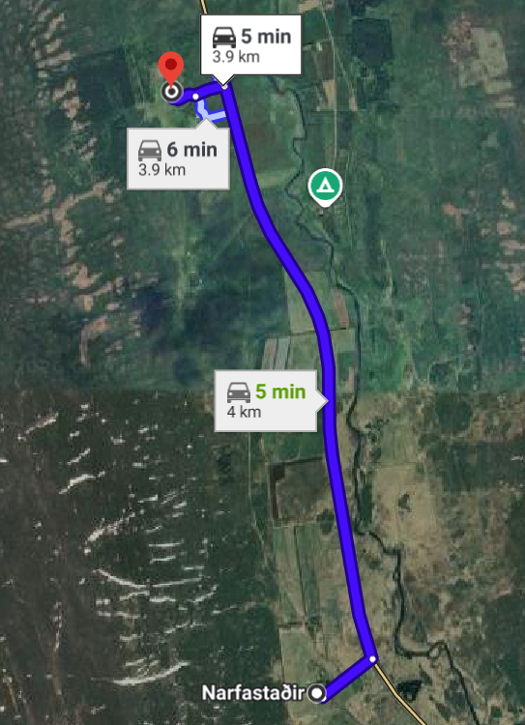
Driving route between Narfastadir Guesthouse and CIAO (approximately 3.9-4.0 km).
- Aurora Farm Hotel — approximately USD 350-400 per room per night; Storu Laugar, 650 Laugar; about 3.6 km from CIAO.
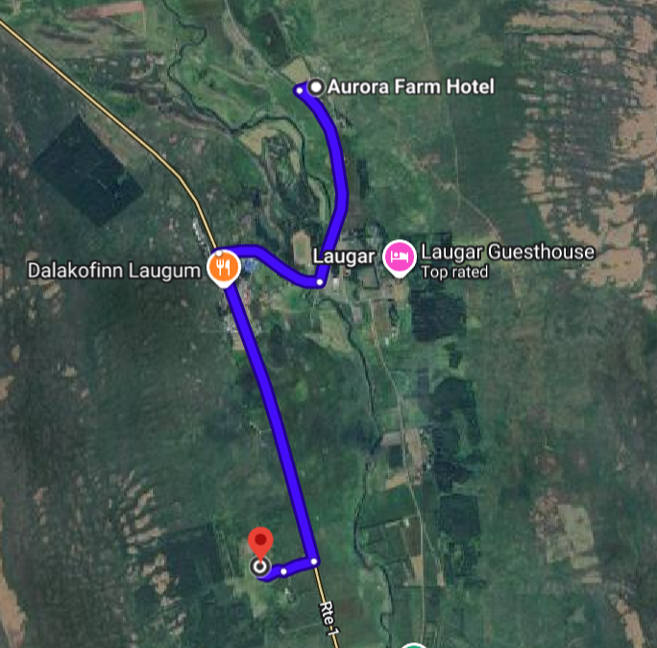
Location of Aurora Farm Hotel near Laugar and CIAO.

In Akureyri
- Hotel Kea by Keahotels — approximately USD 300-350 per room per night; Hafnarstræti 87-89, 600 Akureyri.
- Hotel Norðurland — approximately USD 250-320 per room per night; Geislagata 7A, 600 Akureyri.
Akureyri is approximately 60 km from CIAO. Additional accommodation options and current prices may be found through major booking platforms.
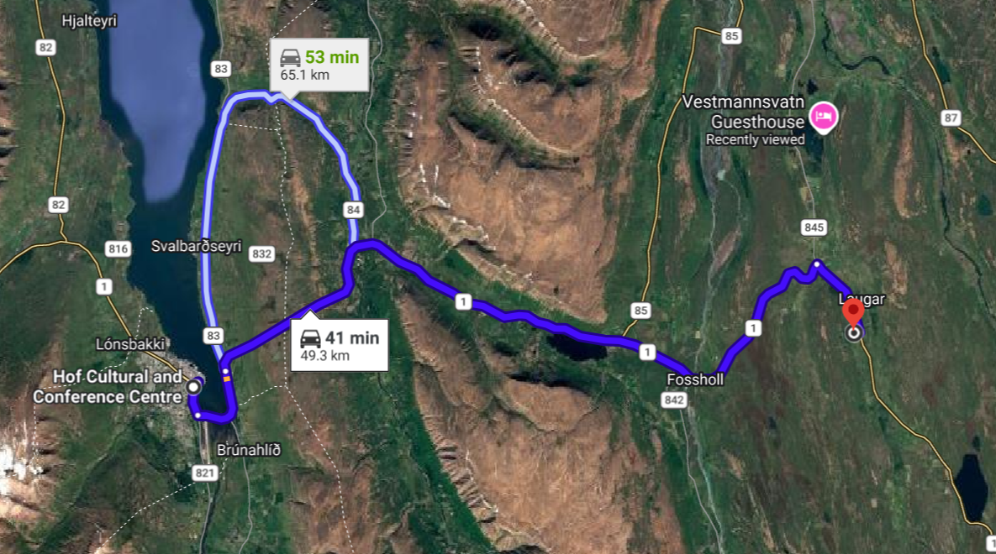
Driving route between Akureyri and CIAO (approximately 60-65 km).

Travel and Transportation
- Participants staying in Akureyri: the organizers will arrange a coach between Akureyri and CIAO during the workshop. The boarding point and daily timetable will be circulated separately.
- Participants staying near CIAO: we recommend that several participants share a rental car. The nearby guesthouses are only a few minutes from the observatory by car. If needed, please contact the organizing team in advance to request a short local pickup, subject to availability.
- General advice: public transport in Iceland is limited, particularly in the area around CIAO. Renting a car is generally the most convenient and flexible option. Participants who drive should check road and weather conditions and choose a vehicle appropriate for the season.

Important Notes
- Programme updates: minor changes may be made to the timetable. Any revisions and practical details will be circulated by the organizing team.
- Advance coordination: participants requesting a local pickup or intending to use the Akureyri coach should share their accommodation and arrival details with the organizing team when requested.
- Weather and roads: late September and early October conditions in northern Iceland can change quickly. Please allow sufficient travel time and carry suitable clothing.

DETAILED SCIENTIFIC PROGRAMME
ISSPMC 2026

Tuesday, 29 September 2026
Opening ceremony from 10:00 to 11:00, followed by academic presentations.
Time | Name | Title | Affiliation | Presentation Title
10:00-11:00 | Opening ceremony
11:00-11:30 | Qiugang Zong | Professor / Director | State Key Laboratory of Lunar and Planetary Sciences, Macau University of Science and Technology | Acceleration, transport, and detection of energetic particles in solar-terrestrial space
11:30-12:00 | Sami Solanki | Professor | Max Planck Institute for Solar System Research (MPS) | New results from Solar Orbiter
12:00-13:30 | Lunch
13:30-14:00 | Sheng Yu | Professor | University of Chinese Academy of Sciences | Interstellar Travel: Today and Tomorrow
14:00-14:30 | Robert Rankin | Professor | University of Alberta | The Ionospheric Feedback Instability: Thin or Thick?
14:30-15:00 | Jie Ren | Professor | China University of Geosciences (Beijing) | Surface waves at the boundary of the plasmasphere and their effects on auroras
15:00-15:30 | Lin Yang | Professor | Shandong University | Computational Spectral Imager for Auroral Observation
15:30-16:00 | Kairui Tai | Postdoc | Chengdu University of Technology | Shock effects on iron-rich olivine and pyroxene: implications for impact-driven multi-sphere coupling on Mars and its moons
16:00-16:30 | Xiangyu Wang | Postdoc | National Space Science Center, Chinese Academy of Sciences | Influence of the twisted magnetospheric tail on the horse-collar aurora under strongly northward oblique interplanetary magnetic field

Wednesday, 30 September 2026
Academic presentations throughout the day.
Time | Name | Title | Affiliation | Presentation Title
10:00-10:30 | Kai Fan | Professor | Institute of Geology and Geophysics, Chinese Academy of Sciences | Dawn-Dusk Asymmetry of Oxygen Ion Loss Above Martian Crustal Magnetic Fields
10:30-11:00 | Yijia Zhou | Assistant Researcher | Shandong University | Giant Undulations Driven by Pitch-Angle Scattering of Time Domain Structures Modulated by Plasmapause Surface Wave
11:00-11:30 | Xinhua Zhao | Professor | National Space Science Center, Chinese Academy of Sciences | Investigation of the differential rotation of the solar atmosphere based on multi-wavelength observations
11:30-12:00 | Feng Zhao | Researcher | Shandong University of Science and Technology | Mass budget of Antarctica from GRACE time-varying gravity observations
12:00-13:30 | Lunch
13:30-14:00 | Si Chen | Researcher | Institute of Geology and Geophysics, Chinese Academy of Sciences | Variations of geomagnetic activity under extreme events with ancient aurora records
14:00-14:30 | Yao Chen | Professor | Shandong University | The FLARE Mission: From Solar Eruptions to Terrestrial Aurora with Cutting-Edge Space-Technology Demonstrations
14:30-15:00 | Shenghao Han | Professor | Shandong University | HAAI-2K: A high-sensitivity all-sky auroral imager for multi-scale auroral observations
15:00-15:30 | Zhiyu Yi | Researcher | Sun Yat-sen University | TBD
15:30-16:00 | Chao Yue | Professor | Peking University | How the Relative Contribution of DP-1 and DP-2 Currents Reshapes the Global Current System During Substorms

Thursday, 1 October 2026
Academic presentations throughout the day.
Time | Name | Title | Affiliation | Presentation Title
10:00-10:30 | Zanyang Xing | Associate Professor | Shandong University | Poleward Boundary Intensifications Associated with the Arrival of Polar Cap Patches
10:30-11:00 | Shengyang Gu | Professor | Wuhan University | Passive optical observations of the middle and upper atmosphere over Yellow River Station
11:00-11:30 | Bing Han | Professor | Xidian University | Substorm Events Retrieval Based on All-Sky Aurora Image Sequences from Zhongshan Station
11:30-12:00 | Xiaowen Yu | Researcher | Chengdu University of Technology | Cryogenic H₂SO₄ weathering of Martian basaltic minerals: dissolution kinetics, secondary sulfate mineralogy, and implications for Hesperian sulfate deposits
12:00-13:30 | Lunch
13:30-14:00 | Quanqi Shi | Professor | Shandong University | Lunar tidal electric field variations caused by coupling between Earth’s atmosphere and magnetosphere
14:00-14:30 | Li Li | Researcher | China University of Geosciences (Beijing) | Effects of Background Magnetic Gradient on the Number of Chorus Wave Elements
14:30-15:00 | Haobo Fu | Assistant Researcher | GFZ German Research Centre for Geosciences | Estimating the Occurrence Conditions of EMIC Waves Using Dual-RBSP Observations
15:00-15:30 | Shuo Yao | Professor | China University of Geosciences (Beijing) | Stronger Substorms and Higher Energy Input Driven by Interplanetary Coronal Mass Ejections Showing Enhanced Helium Abundance
15:30-16:00 | Dedong Wang | Researcher | GFZ Helmholtz Centre for Geosciences | NEOMI SEEP: A Mission Idea for Investigating Wave-Particle Interactions and Energetic Particle Precipitation

Friday, 2 October 2026
Academic presentations throughout the day.
Time | Name | Title | Affiliation | Presentation Title
10:00-10:30 | Jing Liu | Researcher | Shandong University | Redefining SAR Arc Generation: The Competing Roles of Magnetospheric and Ionospheric Energy Injection
10:30-11:00 | Marius Echim | Researcher | Institute of Space Science, Romania; Royal Belgian Institute for Space Aeronomy | Using spectroscopic observations and magnetosphere-ionosphere coupling modelling to estimate the kinetic properties of the magnetospheric generator feeding stable discrete auroral arcs
11:00-11:30 | Catalin Negrea | Researcher | Institute of Space Science | Providing global neutral density estimates using the CTIPe model and data assimilation
11:30-12:00 | Wenrui Wang | Professor | State Key Laboratory of Lunar and Planetary Sciences, Macau University of Science and Technology | Effect of the South Atlantic Anomaly on Aurora
12:00-13:30 | Lunch
13:30-14:00 | Jian Pei | Researcher | Shandong University | TBD
14:00-14:30 | Yuanhao Zheng | Researcher | Shandong University | TBD
14:30-15:00 | Jiannan Zhao | Researcher | China University of Geosciences (Wuhan) | TBD

Saturday, 3 October 2026
Roundtable discussion in the morning; scientific presentations in the afternoon.
Time | Name | Title | Affiliation | Presentation Title
10:00-12:00 | Roundtable discussion
12:00-13:00 | Lunch
14:00-14:30 | Bin Li | Researcher | Polar Research Institute of China | Fragmented Aurora-Like Emissions: A Visualization of Aurora Aroused Ionospheric Instability Ripples
14:30-15:00 | Zejun Hu | Researcher | Polar Research Institute of China | Overview of the China-Iceland Arctic Scientific Observatory and space physics achievements
We look forward to welcoming you to Iceland.
Organizing Committee | ISSPMC 2026

